**CodeHS 2.3.2 & 2.3.5**

**2.3.2**

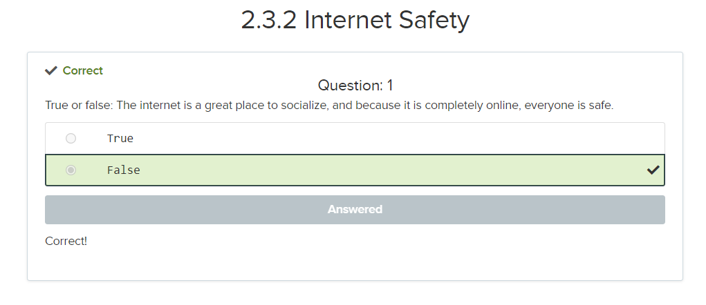

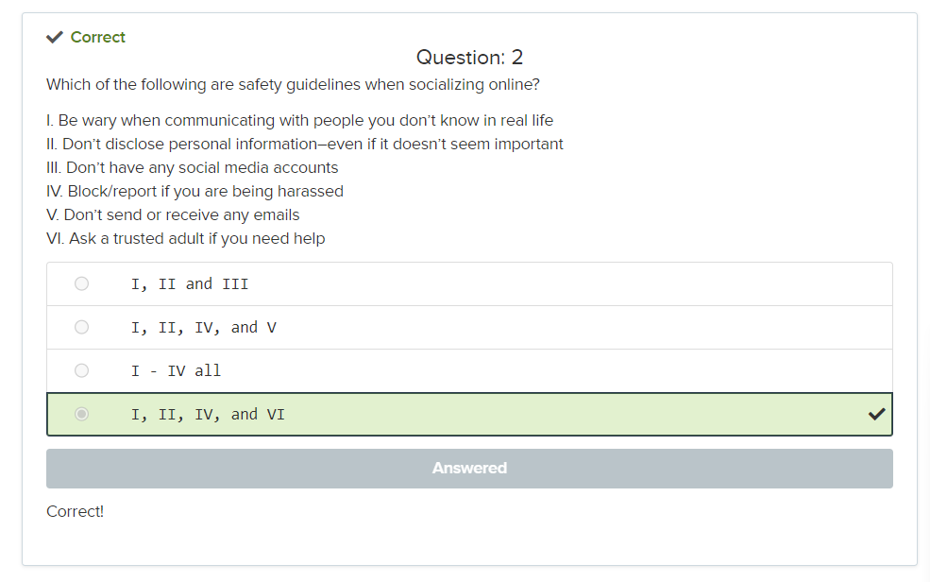

**2.3.5**

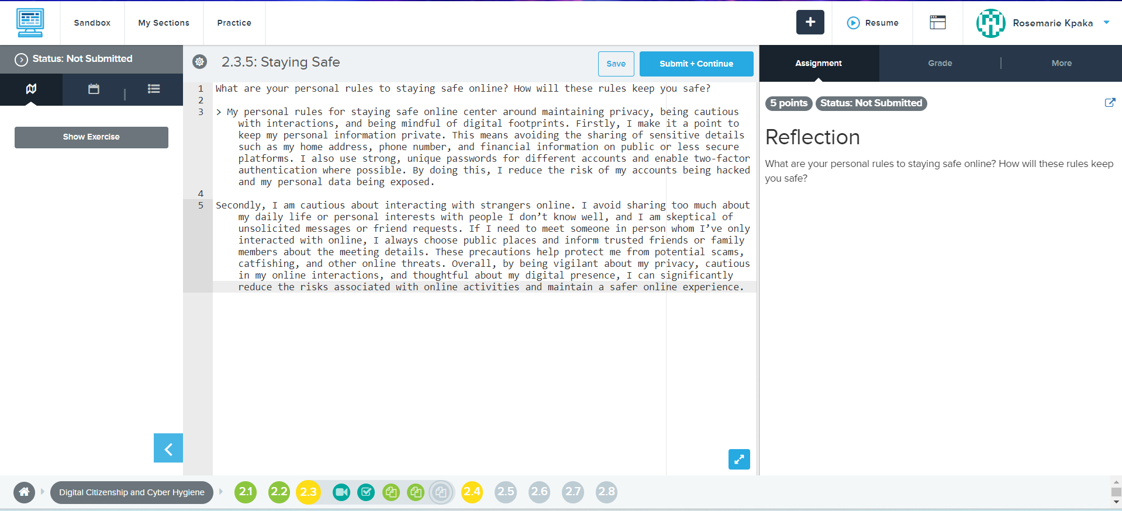

What are your personal rules to staying safe online? How will these rules keep you safe?

* My personal rules for staying safe online center around maintaining privacy, being cautious with interactions, and being mindful of digital footprints. Firstly, I make it a point to keep my personal information private. This means avoiding the sharing of sensitive details such as my home address, phone number, and financial information on public or less secure platforms. I also use strong, unique passwords for different accounts and enable two-factor authentication where possible. By doing this, I reduce the risk of my accounts being hacked and my personal data being exposed. Secondly, I am cautious about interacting with strangers online. I avoid sharing too much about my daily life or personal interests with people I don’t know well, and I am skeptical of unsolicited messages or friend requests. If I need to meet someone in person whom I’ve only interacted with online, I always choose public places and inform trusted friends or family members about the meeting details. These precautions help protect me from potential scams, catfishing, and other online threats. Overall, by being vigilant about my privacy, cautious in my online interactions, and thoughtful about my digital presence, I can significantly reduce the risks associated with online activities and maintain a safer online experience.